SKYNET 3D V2.1

<https://www.facebook.com/skynet3ddevelopment>

<https://www.facebook.com/groups/OFFICIALAnet3DprinterSupportGroup/>

[skynet3ddevelopment@gmail.com](mailto:skynet3ddevelopment@gmail.com) – (FACEBOOK IS THE BEST WAY TO CONTACT ME)

<http://www.ebay.co.uk/usr/skynet3dmods>

**disclaimer** I (scou) am totally not responsible if ‘’you’’’ kill your printer when you modify it from its stock form.. you do so at your own risk.. if you hurt yourself or kill your neighbours cat.. that’s on you too ;) otherwise .. have fun !

This guide will deal with the firmware aspect of the install process. If you need help with wiring your sensor please see the wiring diagrams within the skynet download. If you need anymore help – head over to the facebook group (2nd link at the top of this page). This guide also assumes that you have already had your printer set up with the default anet firmware prior to installation. It also assumes that you have already done some printing on your machine prior to install. This rules out any mechanical problems when people contact me with questions

First were going to assume that you have already downloaded the firmware package. So drag this to your desktop to make the process easier and unzip the entire contents into their respective folders.

* First unzip all files within the download
* Open Arduino 1.6.9 slim folder and then open “arduino.exe”
* Go to “File” “Open”
* Browse to the firmware folder and open “Skynetv2.1’’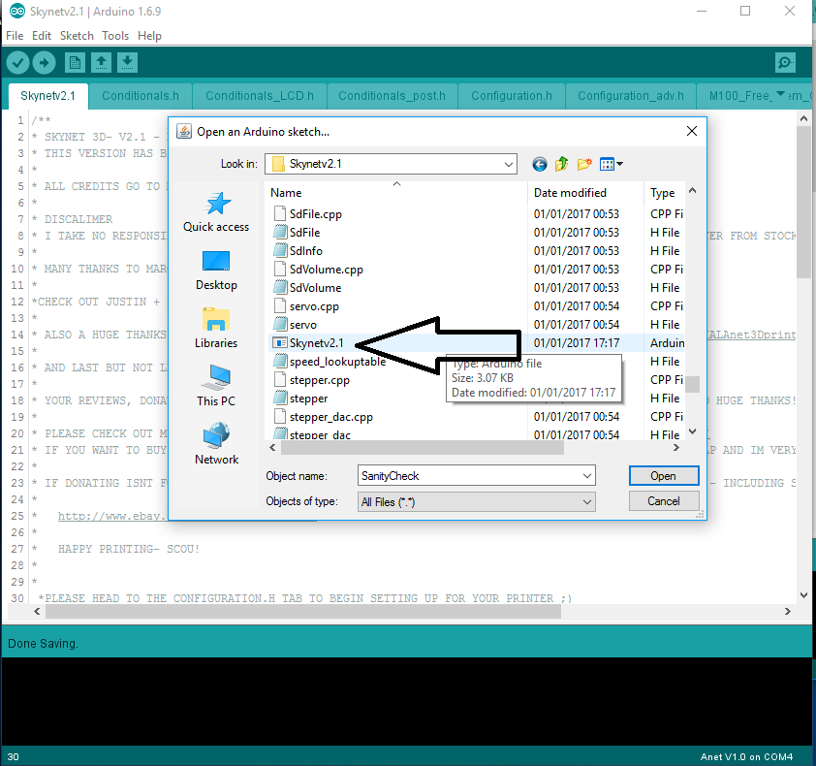
* Go to “Tools” “Board” and select “Anet V1.0” 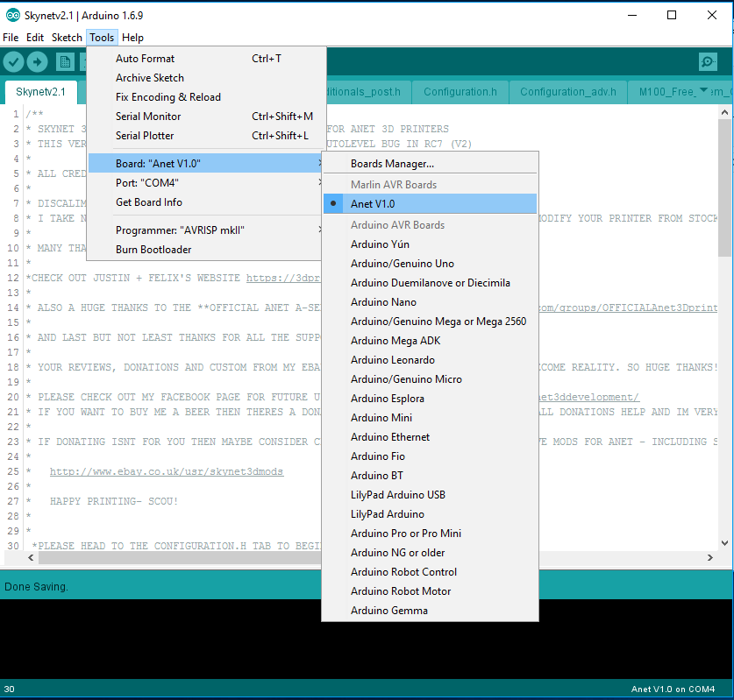
* Go to “Tools” “Port” and Select the relavent com port for your printer, mine is com4
* go to “Tools” “Programmer” and select “AVRISP mkII”

you can check your com port if you go to “device manager” and under “Ports (COM &LPT) you should have “ USB-SERIAL CH340” as shown below 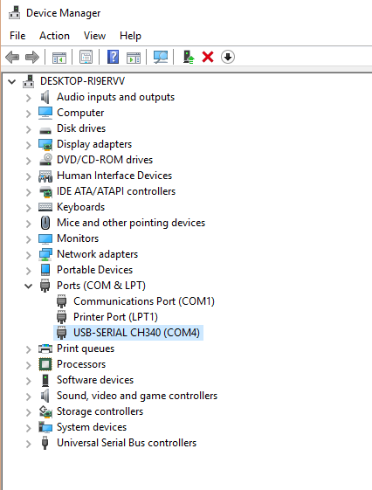

------------------------------------------------------------------------------------------------------------------------------------

This step is very important. If you miss this step then the firmware wont compile and upload!

with skynet v2.1 its easier than ever to switch between configurations- because ive added a config section at the top of the configuration.h to make this process as trouble free as possible. just select your lcd and your probe configuration by uncommenting the correct sections

first you select the correct lcd – if you have a stock a8 select the ANET_KEYPAD_LCD by removing the ‘’//’ (uncommenting) in the line //#define ANET_KEYPAD_LCD

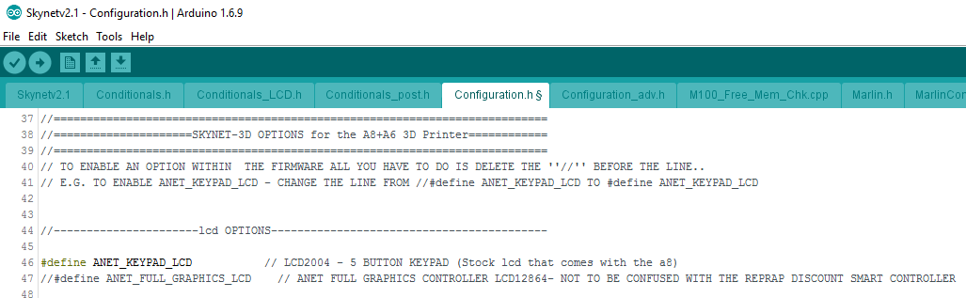

If you have the a6 printer or an a8 with one of my frame mods you would uncomment the line

//#define ANET_FULL_GRAPHICS_LCD

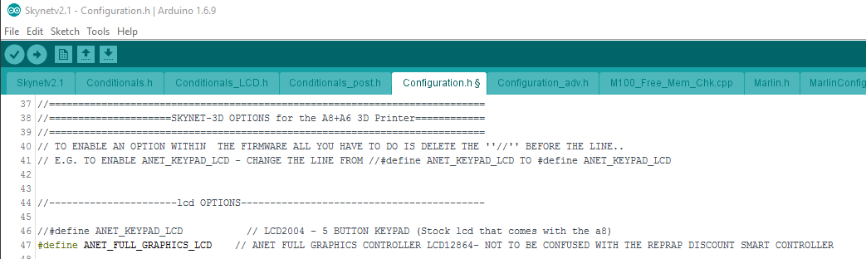

Now you need to select the correct probe configuration depending on what setup you have.. stock a8 with front left tubular sensor- stock a8 with official rear sensor – a6 printer (link to mount included)

Just uncomment every #define line from that given section like so….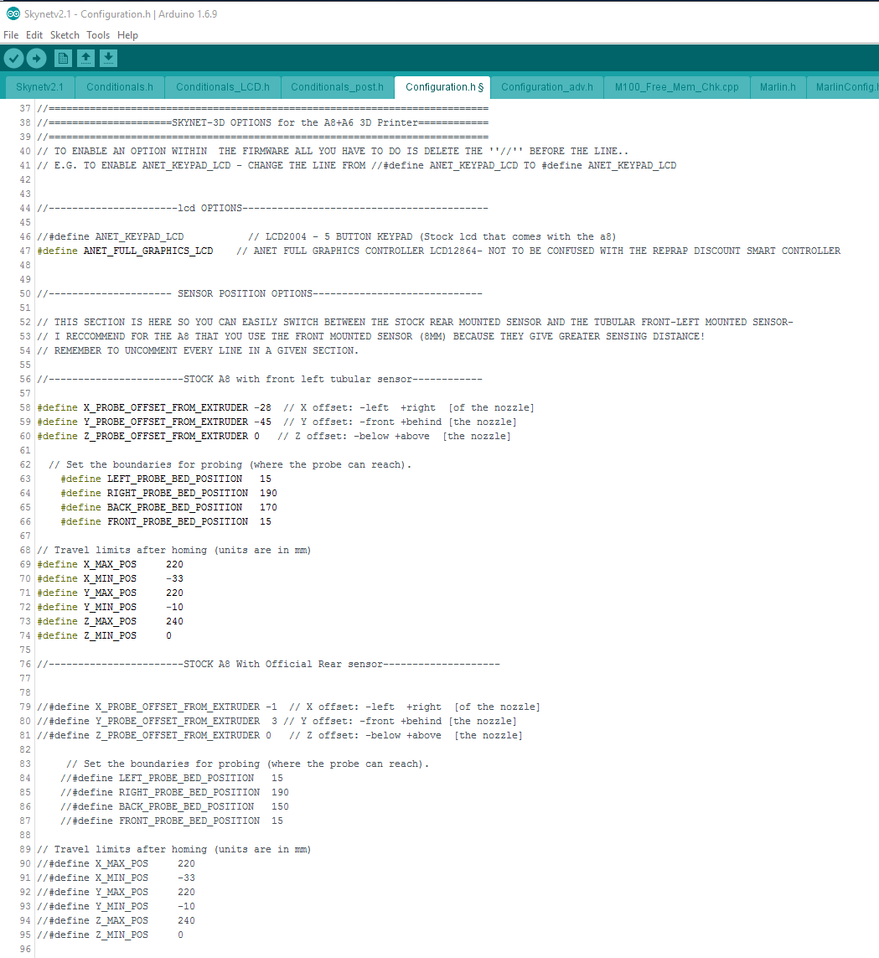

* Click the “upload” Button in arduino and wait for Skynet to compile and upload to your printer

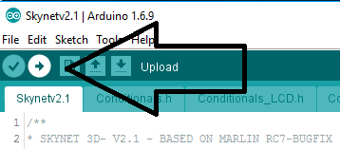

And that’s it!! Once Arduino says “done uploading” and you have the Marlin logo on your printers screen youre done! Well youre done installing you need to carry on to set your z-offset.

Now we configure youre z offset – this is the distance the printer has to travel below zero in order to print because with induction sensors you will home to z and your nozzle will be no where near the bed

* In the Skynetv2 download folder- unzip and install Cura 15.04.6- once installation is complete open it.
* Go to “file” “preferences”
* make sure the “printing window type” is set to “Pronterface UI” 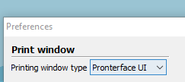
* Go to “Machine” “Machine settings” and copy the setting exatly as below apart from “serial port” which you would set to the same as the previous steps (mine Com4)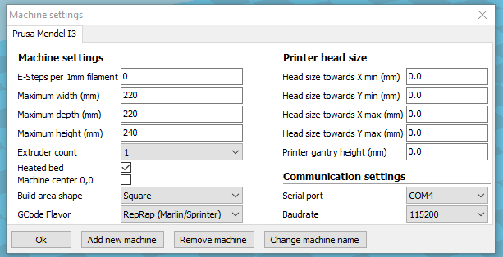
* Now Click on the “load” button and load the “20mm cube.stl” 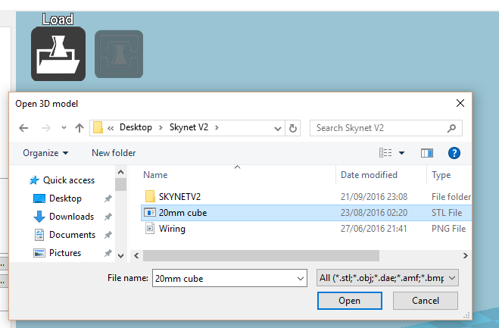

Now you want to set your settings for your chosen material on the left side of cura (printing temps / speed/ infil etc…)

* Click the “Print” button next to “load” and youll get the “Pronterface UI” window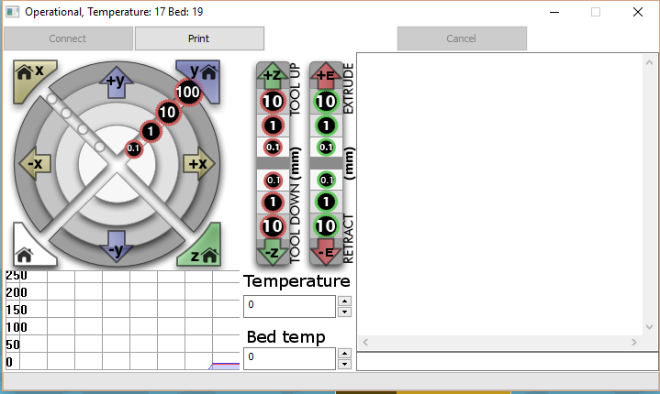

If you don’t have “operational” in this window then you may have set the wrong baudrate or comport in the “machine settings” – just go double check they are right.

* From the pronterface window you can now start controlling your printer via usb!

In the command window type M119 and hit “enter” on your keyboard to check if your Zprobe is “Triggered” below you can see I ran that comand twice – first without a metal object below the sensor and secondly with a metal object below the sensor

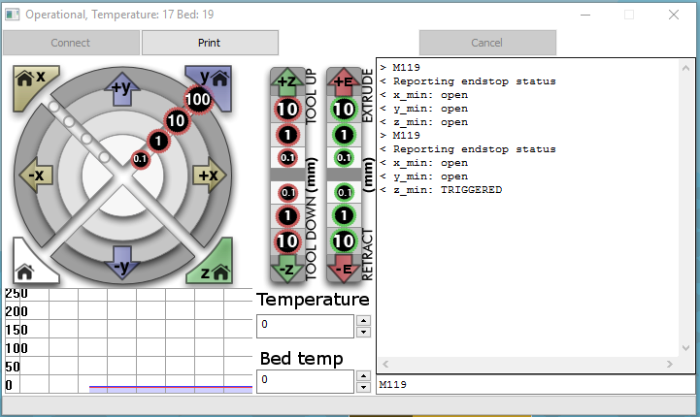

* Now hit the white “home” button to home all axis.

You will notice that the printer will home X and Y and then move the sensor to the center of the bed and lower itself until it is triggered then it will raise to z10..

* No hit the “-z 10” button to bring the nozzle down to Z0
* Place a sheet of a4 copy paper between the bed and the nozzle and lower the z axis in 0.1 incraments using the button until there is just a little bit of friction when moving the paper around.
* Now run an M114 command in Pronterface UI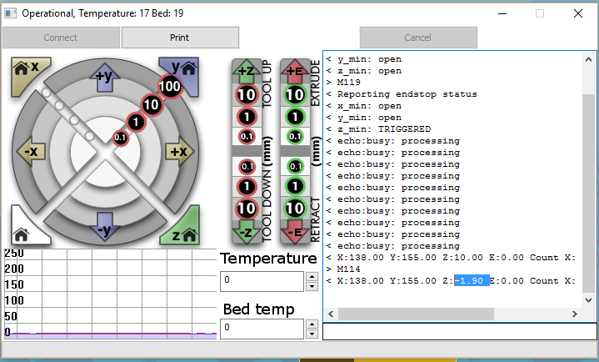

You have now found your offset value – as you can see mine is z: -1.90

* On your printer input pannel press the center button (Select/menu button)
* Go down to “control” -select “motion” -select “Z offset : 0.00” -select and then in the z offset menu press the down button or rotate knob until it reads the desired offset value (mine is -1.90) and press select.
* Then go to “menu” “control” “store memory”

Congratulations – you have now set your z offset value and you are now ready to print!

* Go to the “Start/End-Gcode” tab in cura and copy this gcode (the G29 is the autolevel)

;Sliced at: {day} {date} {time}

;Basic settings: Layer height: {layer_height} Walls: {wall_thickness} Fill: {fill_density}

;Print time: {print_time}

;Filament used: {filament_amount}m {filament_weight}g

;Filament cost: {filament_cost}

;M190 S{print_bed_temperature} ;Uncomment to add your own bed temperature line

;M109 S{print_temperature} ;Uncomment to add your own temperature line

G21 ;metric values

G90 ;absolute positioning

M82 ;set extruder to absolute mode

M107 ;start with the fan off

G28 X0 Y0 ;move X/Y to min endstops

G28

G29

G1 Z15.0 F{travel_speed} ;move the platform down 15mm

G0 X2 Y2 Z2

G92 E0 ;zero the extruded length

G1 F200 E25 ;extrude 3mm of feed stock

G92 E0 ;zero the extruded length again

G1 F{travel_speed}

;Put printing message on LCD screen

M117 Printing...

* 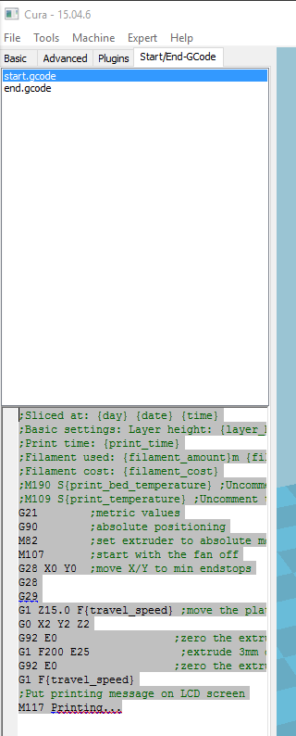

Go back to pronterface and hit “print” – allow your hotend and heatbed to get to temperature and watch in awe as you never have to touch those god forsaken bed screws ever again!!

If you are still not getting the desired first layer go back to the z offset menu in the printer and adjust accordingly until you achieve the desired “squish” – just remember to go back and “store memory” so that your printer remembers your new offset

I hope all that was easy enough to follow.

Thanks to all of you who use and support skynet. If you feel the need to buy me a beer, there is a donate button on the side of my facebook page where you can donate. Every little helps and also if giving away money isnt for you then you may opt for choosing one of my frame modifications – sensor or other goodies at my ebay shop http://www.ebay.co.uk/usr/skynet3dmods. All donations and mod sales all help go towards funding this project and spreading and growing skynet into something beautiful..

Happy printing

Pete @SkyNet3D